StormGeo| Knowledge Transfer Document

Flow 6: DF6: Salesforce Usage Place Holder to NetSuite Usage Flow.

Process: It’s a real time flow, Whenever the new Usage Place Holder record will create in salesforce this flow runs implicitly it will fetch the Usage Place Holder record information from the Salesforce with the help of Salesforce web listener and it will create Usage record in NetSuite accordingly.
Orchestration One: In the first orchestration, we are exporting the usage placeholder details with a status of 'Submitted' from Salesforce using the Salesforce web listener.
Any Script is written in Celigo: No
Any Script is written in NetSuite: No
Complex Formula is added: No
Any JS Hook is added in the flow: No
Any Output Filter is added: Yes, Added output filter “OP_NS_Subscription_Status” field value should not be empty
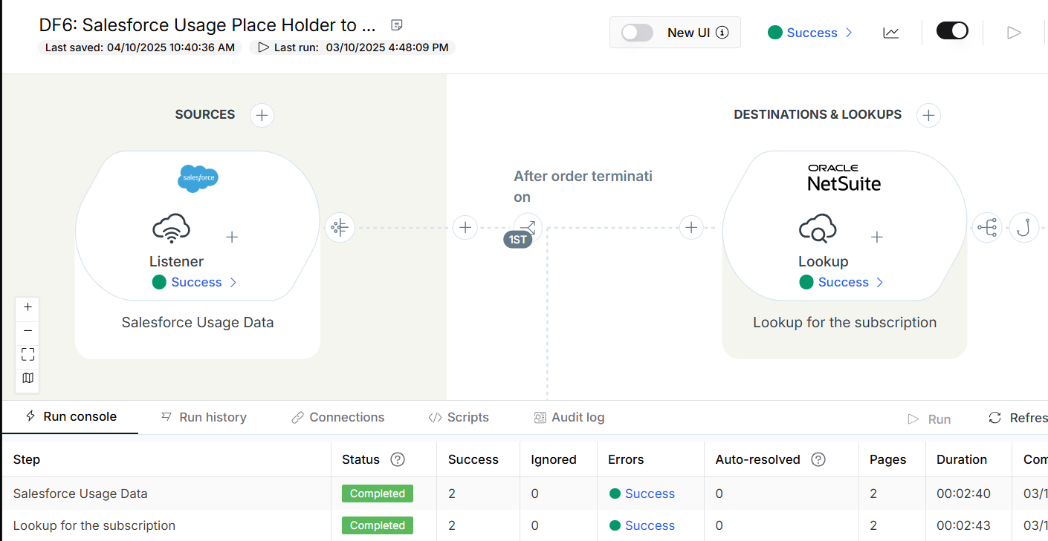
Orchestration Two: In the second orchestration, we are fetching subscription information from the NetSuite order product record through a saved search using a lookup orchestration, based on the order product number. We then forward the subscription name and its internal ID to the next orchestration.
Any Filter is added in the flow: No.
Any Script is written in Celigo: No.
Any Script is written in NetSuite: No
Any Output Filter is added: No
Any JS Hook is added in the flow: Yes.
Any result mapping is added in the flow: Yes, added result mapping in lookup orchestration to pass the Subscription Data to the next orchestration
Any response mapping is added in the flow: No.
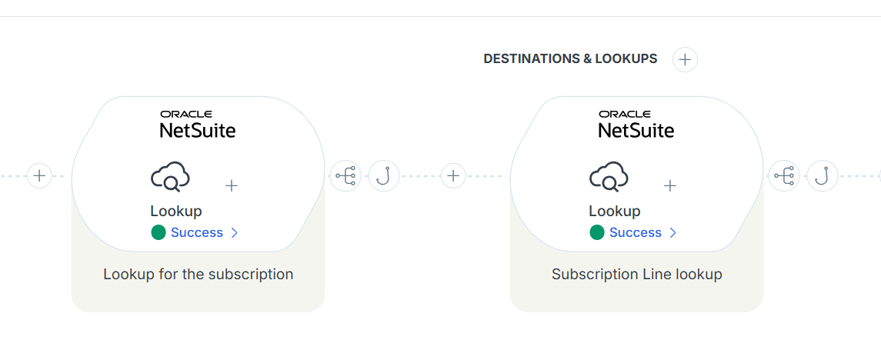
JS HOOK:-
function postResponseMap (options) {
var data = options.postResponseMapData;
for(var i=0;i<data.length;i++)
{
var sf_Order = data[i].OrderProductNumber;
console.log(sf_Order);
var subscriptionData = data[i].SubscriptionData;
console.log(subscriptionData);

for(var j=0;j<subscriptionData.length;j++)
{
var subscriptionSFOrder = subscriptionData[j].SFOrderProductNumber;
console.log(subscriptionSFOrder);
if(sf_Order == subscriptionSFOrder)
{
// data[i].subscriptionId= subscriptionData[j].SubscriptionId;
data[i].SubscriptionName= subscriptionData[j].SubscriptionName.replace(/^\d+\s*/, "").trim();;
data[i].Subscription_Id= subscriptionData[j].Subscription_Id;
}
data[i].SubscriptionData = [];
}
}
return options.postResponseMapData
}

Orchestration Three: In the third orchestration, we are fetching subscription Line information from the NetSuite Subscription Line record through a saved search using a lookup orchestration, based on the subscription internal id. We then forward the subscription Line Number to the next orchestration.
Any Filter is added in the flow: No.
Any Script is written in Celigo: No.
Any Script is written in NetSuite: No
Any Output Filter is added: No
Any JS Hook is added in the flow: Yes.
Any result mapping is added in the flow: Yes, added result mapping in lookup orchestration to pass the SubscriptionLineData to the next orchestration.
Any response mapping is added in the flow: No.
JS HOOK:
function postResponseMap (options) {
var data = options.postResponseMapData;
for(var i=0;i<data.length;i++)
{
var Subscription_Id = data[i].Subscription_Id;
console.log(Subscription_Id);
var subscriptionLineData = data[i].SubscriptionLineData;
for(var j=0;j<subscriptionLineData.length;j++){
var SubscriptionInternalId = subscriptionLineData[j].SubscriptionInternalId;
if(Subscription_Id == SubscriptionInternalId)
{
data[i].SubscriptionLineNumber= subscriptionLineData[j].LineNumber;
data[i].SubscriptionLineStatus= subscriptionLineData[j].Status;
}
}
data[i].SubscriptionLineData = [];
}
return options.postResponseMapData
}

Orchestration Four: In fourth orchestration, we are getting Usage Place Holder record data from Salesforce with the help of Salesforce web listener and we are creating Usage record in NetSuite and adding the mapping for required data field.
Any Input Filter is added in the flow: Yes, Added Input filter “Subscription_Id” field value should not be empty
Any Script is written in Celigo: No.
Any Script is written in NetSuite: No
Any Output Filter is added: No
Any JS Hook is added in the flow: No
Any result mapping is added in the flow: No.
Any response mapping is added in the flow: No.

Mappings:-
Salesforce Fields | NetSuite Fields
Name | Memo
End_Date__c | Usage Date
TotalQuantity | Quantity
Subscription_Id | Subscription (InternalId)
Description__c | Description (modified)
Salesforce_UsageId | External ID
Salesforce_UsageId | Salesforce UPH Id
{{SubscriptionName}}: {{SubscriptionLineNumber}} | Subscription Line (Name)
"true" | Ignore Mandatory Fields

Orchestration Five: In the fifth orchestration, we are fetching subscription information from the NetSuite usage record through a saved search using a lookup orchestration, based on the netsuite usage internal id. We then forward the subscription status to the next orchestration.
Any Input Filter is added in the flow: Yes, added Netsuite Usage Internal Id should not be empty.
Any Script is written in Celigo: No.
Any Script is written in NetSuite: No
Any Output Filter is added: No
Any JS Hook is added in the flow: No.
Any result mapping is added in the flow: Yes, added result mapping in lookup orchestration to pass subscriptionStatusData to the next orchestration.
Any response mapping is added in the flow: No.
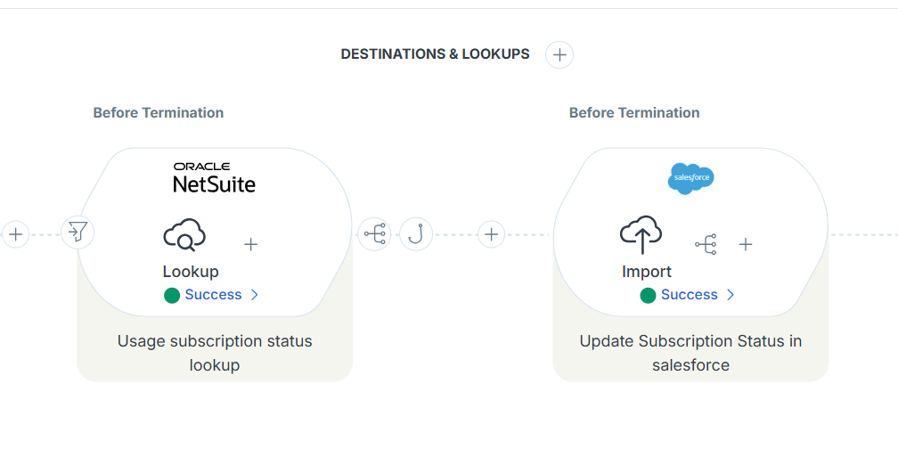

Orchestration Six: In the Sixth orchestration, we updating the Usage record Subscription status on Usage Place Holder record in Salesforce from NetSuite after usage record creation and adding the necessary data field mappings.
Any Input Filter is added in the flow: Yes, added Netsuite Usage Internal Id should not be empty.
Any Script is written in Celigo: No.
Any Script is written in NetSuite: No
Any Output Filter is added: No
Any JS Hook is added in the flow: No.
Any result mapping is added in the flow: No.
Any response mapping is added in the flow: No.
Mappings:-
Salesforce Fields | NetSuite Fields
SubscriptionStatusOnUsage | NS Subscription Status
"true" | UPH Updated

Orchestration Seven: In the seventh orchestration, we retrieve Usage Placeholder record data from Salesforce where the 'Make Usage Void' checkbox is checked to handle incorrectly created usage entries. Using the Salesforce web listener, we then update the corresponding Usage record in NetSuite and add the necessary data field mappings.
Any Input Filter is added in the flow: No.
Any Script is written in Celigo: No.
Any Script is written in NetSuite: No
Any Output Filter is added: No
Any JS Hook is added in the flow: No
Any result mapping is added in the flow: No.
Any response mapping is added in the flow: No.
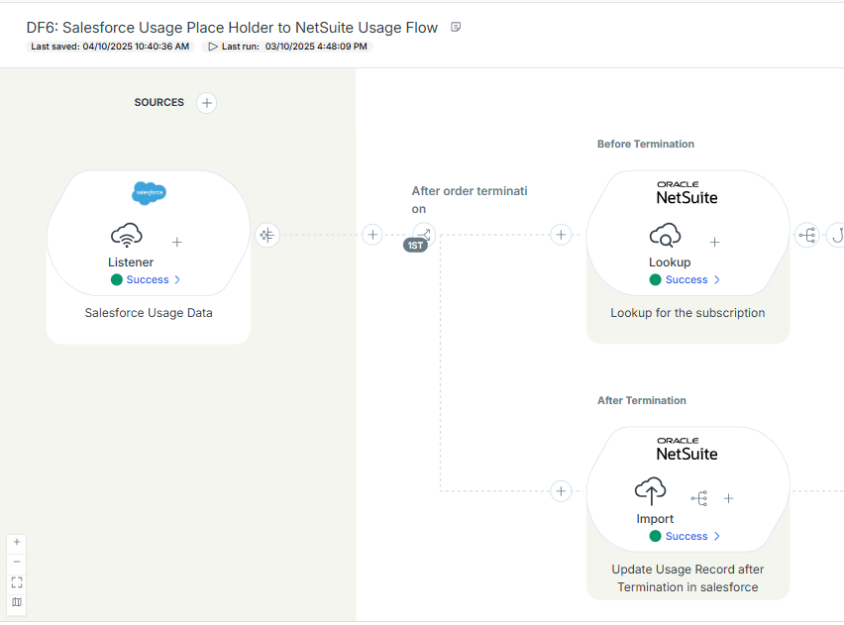
Mappings:-
Salesforce Fields | NetSuite Fields
“true” | Send for voiding

